Saving Nature – Lough Neagh Landscape Partnership
Lough Neagh, its waterways, and its surrounding wetland habitats are world renowned. However, more needs to happen to help nature survive and expand here. This can be done in a way that sees people live sustainably within this rich landscape. Our work is about connecting people to nature in a way that creates a shared vision locally and wins the hearts and minds of those who call this landscape.
Local community will be aware that Lough Neagh Landscape Partnership (LNLP) have been meeting with Department of Education over the last two years to discuss a lease for the areas outlined in the map attached to this bulletin.
There will be a project introduction on Friday 12th April – at Derrytresk Community Hall starting at 7pm – all the team will be present with information on what they will be doing this summer – This will be an opportunity to come along and chat to us, take a look at the lease maps, point out any areas you have any queries on, and look at ways you would like to engage with us over the coming summer and indeed next two years of the project. The event will be relatively informal, and there will be stew, and apple pie for all attending. Music will be provided by the local Comhaltas group.
Department of Education have provided details of the lease area and have agreed to an initial 20 year lease of the lands by Lough Neagh Partnership. This lease is being finalised currently and LNLP are now at the stage where we can progress our community engagement.
The works are being delivered through funding from “The national Lottery Heritage Fund” through a project called - Saving Nature around Lough Neagh – This project is a vision for restoring, rebuilding and reconnecting landscapes and people. Promoting landscape-scale conservation at key sites in the wider Lough Neagh area, and unlocking resources to deliver action - targeting Newferry peatland near Lough Beg, and the peatlands in the Derryloughan/Derrytresk area of south-west Lough Neagh.
LNLP has huge potential through this saving nature project to influence the hearts and minds of people in and around Lough Neagh, helping them work collectively and agree a shared vision for the area they live and work in.

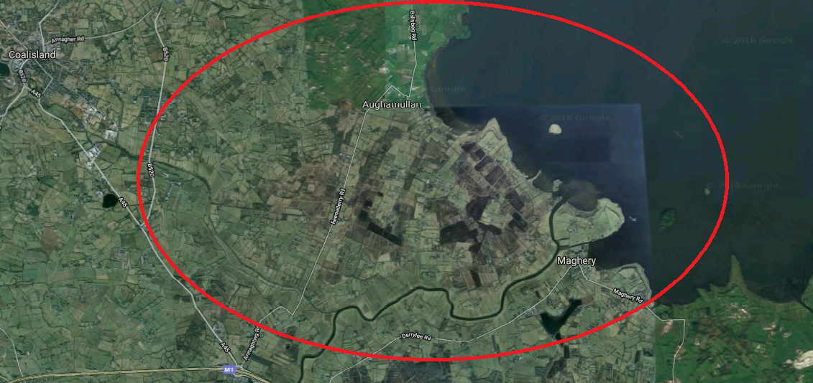

Main Objectives of LNLP Saving Nature project on Department of Education Lands.
- Engage with Community
- Conserve Curlew population
- Restore and improve habitat for Curlew – including peatland & wet grassland
Engage with Community
LNLP recognises that to generate a deep rooted and beneficial outcome for this project (and look towards the Community asset transfer of the lands from Department of Education to community) that a sensitive unhurried and in-depth engagement is needed.
Through a series of engagements across workshops, artwork, farm/land management delivered by Quarto, we hope to deliver a sustainable relationship with all involved, by providing opportunity for communities to voice and represent their perspective – in turn we hope this will result in a sense of empowerment for communities as they make clear what they want and need.
LNLP are focusing on engaging community with the landscape and seeing what community would like to use the landscape for. One of the priority areas we will be working on through this project will be the conservation of the Curlew population in this area – Curlew has declined by 96% in the last 10 – 15 years and this landscape is still supporting a number of pair. We will aim to work with local landowners and farmers to support these birds and ensure they remain a part of your Landscape.
Conserve Curlew population
LNLP alongside partners RSPB NI have identified the monitoring of the Breeding Curlew population in this area, as being an integral part of the Saving Nature project. KRC Ecology will help increase our understanding of how the Curlew are using this area, as well as engaging with the local community, and building a positive profile for Curlews in the area.
LNLP from this work would like to gain a better understanding on how the Curlew are using the department of education and surrounding land and the threats they are facing, as well as look at ways we can improve the area for the conservation of the Curlew in the future.
Local community have a strong interest in the local Natural Heritage of the area, and through our Saving Nature project we will be exploring the relationship that exists between them and their landscape, part of this we will be collecting stories and memories the community have of Curlew and other Breeding waders that use the landscape.
One of the original primary objectives of our overarching Saving Nature project is to restore the peatland habitat and wet grassland for birds, waders and other wildlife that live alongside the people and community, in and around the Lough Neagh shore.
Collection of Local community history
We will also seek to collect oral and written histories of local community’s memories -, - These Department of Education Bogs have been part of the consciousness of this landscape for centuries, there are stories and associations with them that local community have weaved and shaped, some of these reflect cultural windows to the past, the traditions of cutting turf, using the ramparts as walk ways to connect community, of how you used these lands, stories of family days to the bog, memories of Corncrake calling in the area - and some reflect the challenges of engaging community in a landscape that can be seen as having only an economic value.
This will include the gathering of old photographs of the area which we can scan and save onto a website for local community to access.

Point of contact for the community
The main contact for the project is Siobhan Thompson – Siobhan is the Natural Heritage officer for the project, and is happy to discuss all elements of the project with anyone who is interested. Siobhan is also the person to contact if you are interested in working with any of the team members outlined below – Messages will be passed on.
Siobhan.thompson@loughneaghlp.com 07927961623 – Mobile number
Teams working with LNLP March – September 2019.
- Oral histories and community engagement – Quarto - Bryonie Reid/Gemma Reid – This team will lead on the community engagement element of the project – their remit is to work with everyone in the area who wishes to engage to initiate a process of examining and understanding the multiple ways in which communities relate to their landscapes - for LNLP this is with particular reference to the Curlew, local peatlands and other wildlife.
Quarto will engage with communities across a wide range of topics, including cultural, historical, reminiscence, and subjects the community initiate discussion on.
- Visioning of the landscape and Workshops – Rosalind Lowry - will produce an initial landscape vision of what the lands could look like that will then be used to generate discussion – what people find appealing about it, what they dislike, how they would alter it.
Rosalind will also deliver five workings where community can explore through art what the lands mean to them and what opportunities they see in the landscape.
- Curlew Monitoring - KRC Ecology – Kendrew Colhoun and Kerry Mackie – this team of Ornithologists will establish what areas of the land are being used by Curlew, and what we can do to enhance the area for the Curlew – the team will also engage with local landowners and farmers to discuss opportunities available
- Curlew school engagement – Declan Coney – Declan is local to the area and has been monitoring curlew/breeding waders and other wildlife in the area over his life. He will engage with local schools and share his knowledge and experience of the area
- Environmental Farm Scheme – Mike Meharg/Chris McCarney Lough Neagh Partners currently have a group scheme working with farmers and landowners around the Lough Neagh shoreline to manage the habitat and important species on the Lough. There are financial incentives offered for farmers/landowners working towards the conservation of breeding waders – this team will be available to provide advice etc. on navigating the scheme and getting the most out of it for the benefit of Curlew.
Facebook
https://www.facebook.com/loughneaghlp/
https://www.facebook.com/loughneaghpartnership/

